**Hiring Process Analysis**

Excel Project

Dasharath Nikam

IrizproTraining institute

**Contents**

1. Project Description
2. Project Approach
3. [Tech Stack Used](https://medium.com/@avi22nayak/hiring-process-analytics-c4757c820826#c3c3)
4. [Data Cleaning](https://medium.com/@avi22nayak/hiring-process-analytics-c4757c820826#7e10)
5. [Result](https://medium.com/@avi22nayak/hiring-process-analytics-c4757c820826#964b) and [Insights](https://medium.com/@avi22nayak/hiring-process-analytics-c4757c820826#ee1d)
6. [Links](https://medium.com/@avi22nayak/hiring-process-analytics-c4757c820826#4917)

**Project Description:**

This project aims to analyze the company's hiring process by evaluating key recruitment metrics such as gender distribution, salary trends, departmental hiring proportions, and position tier distribution. By gaining valuable insights from this analysis, the goal is to refine hiring strategies, identify patterns, and support more informed decision-making in workforce planning.

We are working on company's hiring process as Data Analyst and the company has provided with the data records of their previous hiring



**Project Approach:**

The approach includes gathering and refining the dataset, managing missing values, identifying and correcting outliers, and extracting key insights. Microsoft Excel is utilized for statistical analysis and basic visualizations, while Tableau enhances the process with advanced graphical representations to effectively uncover hiring trends and patterns.

**Tech Stack Used**

1. Microsoft Excel 2019 — A spreadsheet editor software used mainly by professionals to enter data in table format, perform computations, plot graphs etc. Here Microsoft Excel is used to filter data and plot graphs to get insights about hiring process of the organization.



**Data Cleaning**

**Handling Missing Values**

1. Column event_name has 15 rows with “-“ as its values. These can be termed as Null values. We replaced it with “Don’t want to say” as they both implies the same thing in context of this project i.e. gender of the candidate is not known.
2. Column Offered Salary has 1 row with Null Value. The corresponding value in Department column is “Sales Department” and Post Name is “i7”. So we replaced it with 0 for Offered Salary for Sales Department and i7 Post Name.
3. Column Post Name has 1 row with “-“ as its value. It can be termed as Null value. The corresponding value in Department column is “Sales Department. So, we replaced it with majority count of Posts for candidates in Sales Department which is “c9”.

**Error in typo**

1. Column Post Name has a category “c-10” which seems to be a typo and the correct category should be “c10” which we changed.

**Result and** [**Insights**](https://medium.com/@avi22nayak/hiring-process-analytics-c4757c820826#ee1d)

**A. Hiring Analysis:**The hiring process involves bringing new individuals into the organization for various roles.

* **Task:**Determine the gender distribution of hires. How many males and females have been hired by the company?



**Insight:  
—**More than half of the hired candidates are **Male** and only **39.51%** of them are **Female**. The rest haven’t disclosed there’s Gender.

**B. Salary Analysis:** The average salary is calculated by adding up the salaries of a group of employees and then dividing the total by the number of employees.

**Your Task:** What is the average salary offered by this company? Use Excel functions to calculate this.



**Insight:  
—**The Average Offered Salary is  **49752.90**

**C. Salary Distribution:** Class intervals represent ranges of values, in this case, salary ranges. The class interval is the difference between the upper and lower limits of a class.

**Your Task:** Create class intervals for the salaries in the company. This will help you understand the salary distribution.

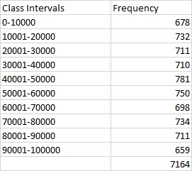

**Insight**

We can observe that maximum offered salary is in the interval of **salary 40001–50000**while minimum offered salary are in intervals of **salary  90001–100000**and **salary  0–10000**. That is most of the job requirement was for middle experience posts and

**D. Departmental Analysis:** Visualizing data through charts and plots is a crucial part of data analysis.

**Your Task:** Use a pie chart, bar graph, or any other suitable visualization to show the proportion of people working in different departments.

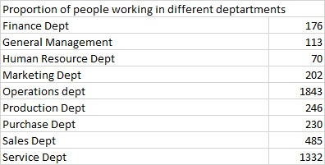

**Insight:  
—**From the above chart, we can observe that most candidates are hired in **Operations Department**and then **Services Department**and **Sales Department**and the less candidates are hired in **Human Resource Department**.

**E. Position Tier Analysis:** Different positions within a company often have different tiers or levels.

**Your Task:** Use a chart or graph to represent the different position tiers within the company. This will help you understand the distribution of positions across different tiers.

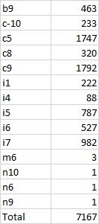

* **Insight:  
  —**Here, we can observe that the organization has hired most candidates for post tier **c9** followed by **c5**and then **i7**at distant third.

**LINKS:**

https://docs.google.com/document/d/1sG5F_NfC0DMCHfqTjEbzNmFAPJ0-fgQg/edit?usp=sharing&ouid=107733368419909055145&rtpof=true&sd=true